|  |  |
| --- | --- |
|  | **FPT ACADEMY INTERNATIONAL**  **FPT – APTECH COMPUTER EDUCATION** |

**Centre Name: ACE-HCMC-2-FPT.**

**Address: 590 Cach Mang Thang 8, District 3, Ho Chi Minh City, Viet Nam.**

ImitationJewelry

|  |  |  |
| --- | --- | --- |
| **Supervisor.** | Mr. Nguyen Phat Tai | |
| **Batch.** |  | |
| **Group.** | Group 2 | |
| **Serial No.** | **Enrollment Number** | **Student Name** |
| 1. | Student1319976 | Tất Hồng Đức |
| 2. | Student1318430 | Ngô Trung Tín |

Month 09 Year 2021

**This is to certify that**

**Mr.:**

Ngô Trung Tín

Tất Hồng Đức

**has successfully designed & developed**

eProject: ImitationJewlry

**Submitted by:**

1. **Ngô Trung Tín**
2. **Tất Hồng Đức**

**Date of issue: 11-Oct-2021**

**Authorized Signature: Ngo Trung Tin & Tat Hong Duc**

**TABLE OF CONTENTS**

FPT – APTECH COMPUTER EDUCATION 1

ACKNOWLEGMENT 4

SYNOSIS 4

PROBLEM DEFINITION 4

CUSTOMER'S REQUIREMENTS SPECIFICATIONS (CRS) 5

Business/Project Objective: 5

Hardware/ Software Requirements: 6

SCOPE OF THE WORK (IN BRIEF) 7

Architecture and design of the system 8

Diagram of the website 9

TASK SHEET REVIEW 1 10

# ACKNOWLEGMENT

On behalf of all the members of group 2, I would like to thank you all for the hard works, supports to make this eProject complete successfully. Especially, Mr. Nguyen Phat Tai, our teacher, he helped us a lot from the day that we started to study at FPT Aptech. With this eProject, he has guided us with his enthusiasm and rigorous, because of his guiding, we would be able to finish this project. Besides, I want to thank all the team member of group 2, each of the team members has been working continuously in 4 weeks in order to complete this project. The last but not least, we would like to say thank you to our family for always supporting us, creating the best conditions for us to focus on the project, and putting faith in the dreams we pursue.

# SYNOSIS

“PASCAL IMITATION JEWELLERY” is one of the leading manufacturers and suppliers of Precious, Semi- precious and Artificial Jewelry. They sell them under different brand names. The Quality of the products are renowned for striking features such as smooth polish, stunning design and excelling clarity, look and feature, luster. The shop owner wishes to have the website of the jeweler shop where in they want to describe all the type, brands of the product.

# PROBLEM DEFINITION

The Web site is to be created based on the following requirements.

1. Home page with describe the keywords or highlight of the shop along with all navigation link defined.
2. Categorized menu which will include Brand image.
3. Sub-category with the type:
   1. Original.
   2. Semi-Precious.
   3. Artificial.
4. Product with the image adding in website.
5. Comparison of the product included all between Original – Semi Precious and Artificial.
6. Contact Us page.
   1. Company address 🡪 displayed using GeoLocation API (eg. GoogleMaps).
   2. Email address. 🡪 when clicked will invoke the local mail client from where they can send an email.
7. About Us.
8. Feedback Form (included feedback content required input).
9. Gallery section should include most common instruments along with their necessary details.
10. There should be a section which will enable user to know latest developments in the field
11. Navigation needs to be smoother.

# CUSTOMER'S REQUIREMENTS SPECIFICATIONS (CRS)

**Client:** PASCAL IMITATION JEWELLERY.

### Business/Project Objective:

The Objective of this program is to give a sample project to work on real life projects. These applications help you build a larger more robust application.

The objective is not to teach you JavaScript/Dreamweaver but to provide you with a real life scenario and help you create basic applications using the tools.

You can revise the chapters before you start with the project.

This project is meant for students who have completed the module of ***HTML5***. These programs should be done in the Lab sessions with assistance of the faculty if required.

It is very essential that a student has a clear understanding of the subject. Students should go through the project and solve the assignments as per requirements given.

Kindly get back @ [eprojects@aptech.ac.in](mailto:eprojects@aptech.ac.in) in case of any doubts regarding the application or its objectives.

**Input to the system:**

* + - * Browsing products based on brands, type of Jewelry products.

**Output from the system:**

* A menu that will categorize all the functions of the site.
* Display the list of available albums category wisely.
* Perform the search based on a particular: brands, type of products.
* Site should be able to provide brief introduction/history under About Us page.
* The location of the showroom under Contact-Us page.
* Besides the above requirements, the site should have look and feel as per the industry standards.

**Expected delivery date:** 11-Oct-2021.

**List of deliverables:**

* + - * Document Word.
      * User Guide.
      * Source code.

### 

### Hardware/ Software Requirements:

* **For developer**

**Hardware**

* + Intel Pentium 4 processor or higher
  + 1 Gigabytes of RAM or higher

**Software**

* + Windows 7 OS or higher
  + Adobe Dreamweaver
  + Web browsers such as IE, Chrome or Firefox are supporting HTML5, CSS3 and Javascript.
* **For web users**

**Hardware**

* + Intel Pentium 4 processor or higher
  + 512 Megabytes of RAM or higher

**Software**

* + Windows XP OS or higher
  + Web browsers such as IE, Chrome or Firefox are supporting HTML5, CSS3 and Javascript.

# SCOPE OF THE WORK (IN BRIEF)

After a long and detailed discussion, our group has decided to create a website contain the following webpages:

1. **Home page**: Display basic information about Jewelry products and which specially products.

2. **Sub-Category**: Includes Product types, definition, the Brand with images / description of (Original, Semi -Precious, and Artificial).

3. **Product:** image adding in website.

4. **Gallery**: image of all Brand Jewelry product related (Original, Semi -Precious, and Artificial).

5. **Comparison menu:** descript Jewelry product with image between Original, Semi -Precious, and Artificial.

6. **Contact Us**: Company address and mail address.

7. **About Us:** About Pascal Imitation Jewelery.

8. **Feedback form:** display the box to input Feedback content.

9. **Gallery**: a library of Jewelry images of Original, Semi -Precious, and Artificial.

10. **Navigation**.

# Architecture and design of the system

Webpage request



Requested Page

**RENDERING**

**ENGINE**

**CSS3**

**HTML5**

**WEB SERVER**

**WEB BROWSER**

**CLIENT**

**SERVER**

# Diagram of the website

.

HOME

PRODUCT

CONTACT US

ABOUT US

FEED-BACK FORM

SUB-CATEGORY

GALLERY & COMPARISON



# TASK SHEET REVIEW 1

|  |  |  |  |  |  |  |  |
| --- | --- | --- | --- | --- | --- | --- | --- |
| **Project Ref. No.:**  **eP/Advertisement Portal Management**  **System/01** | | **Project Title:** | **Activity Plan Prepared By:** | **Date of Preparation of Activity Plan:** | | | |
| **Sr.**  **No.** | **Task** | **Actual**  **Start Date** | **Actual Days** | **Team**  **Mate Names** | **Status** |
| 1 | Problem Statement | **ImitationJewelry** | Duc | 12/09/2021 | 1 | Duc | Completed |
| 2 | Analysis of Jewelry requirements about the website | 13/09/2021 | 1 | Duc | Completed |
| 3 | The scope of the work (in brief) | 14/09/2021 | 1 | Duc | Completed |
| 4 | Architecture and design of the system | 15/09/2021 | 1 | Tin | Completed |
| 5 | Diagram of the website | 17/09/2021 | 1 | Tin | Completed |
| 6 | Task Sheet | 20/09/2021 | 1 | Tin | Completed |

|  |  |
| --- | --- |
| **Date:** | |
| Signature of Instructor:  **Mr. Nguyen Phat Tai** | Signature of Team Leader:  **Mr. Ngo Trung Tin** |

# SITE MAP

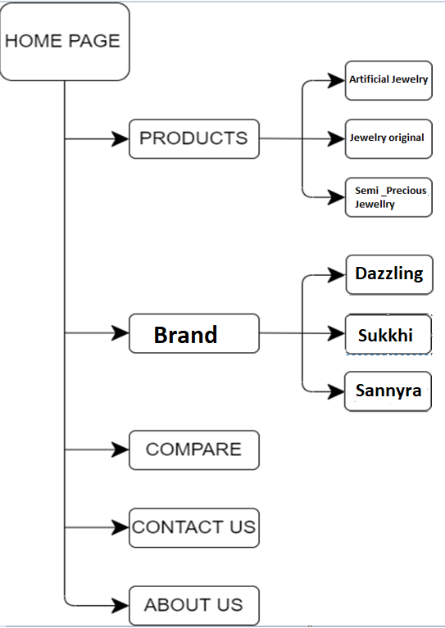

# MOCK OF THE WEBSITE

1. **HOMEPAGE**

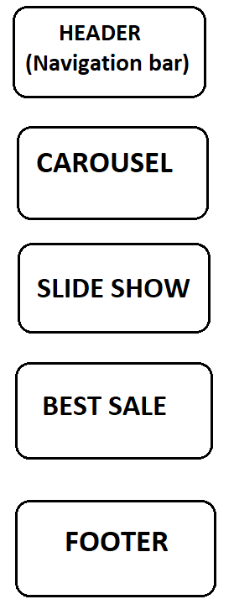

1. **PRODUCTS**

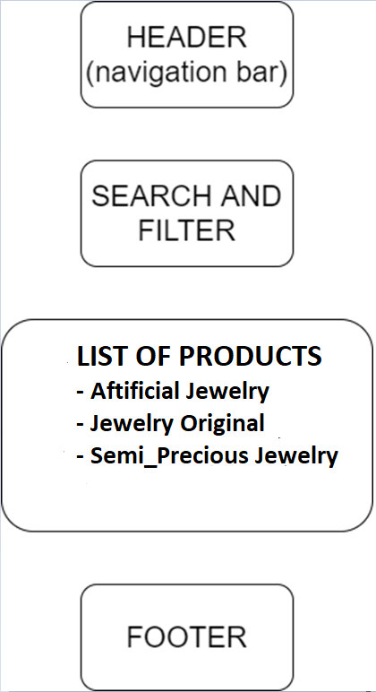

1. **BRANDS**

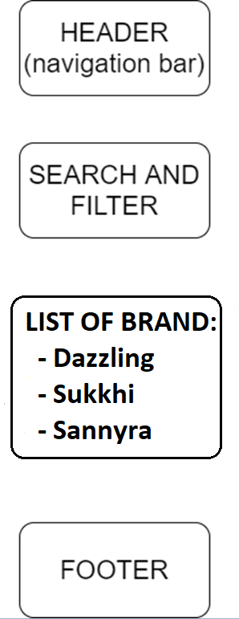

1. **COMPARE**

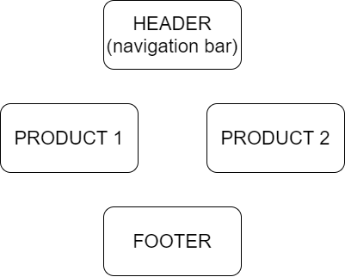

1. **CONTACT US**

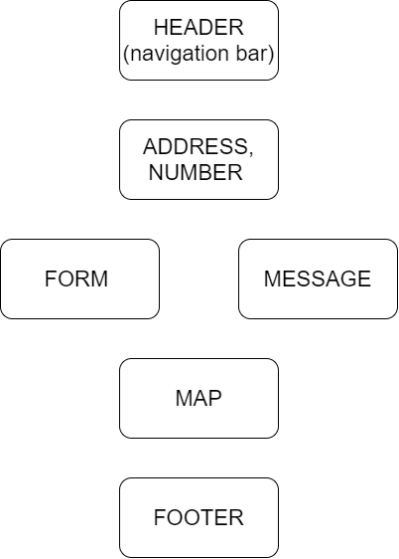

1. **ABOUT US**

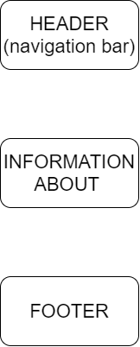

# TASK SHEET REVIEW 2

|  |  |  |  |  |  |  |  |
| --- | --- | --- | --- | --- | --- | --- | --- |
| **Project Ref. No.:**  **eP/Advertisement**  **Portal Management System/01** | | **Project Title:** | **Activity Plan Prepared By:** | **Date of Preparation of Activity Plan:** | | | |
| **Sr.**  **No.** | **Task** | **Actual**  **Start Date** | **Actual Days** | **Team**  **Mate Names** | **Status** |
| 1 | Site map | **ImitationJewelry** | Duc | 28-Sep-2021 | 1 | Duc, Tin | Completed |
| 2 | Mock of the website | 28-Sep-2021 | 1 | Duc, Tin | Completed |
| 3 | Task Sheet | 29-Sep-2021 | 1 | Duc, Tin | Completed |

|  |  |
| --- | --- |
| **Date:** | |
| Signature of Instructor:  **Mr. Nguyen Phat Tai** | Signature of Team Leader:  **Mr. Ngo Trung Tin** |

# WEBSITE DESCRIPTION

1. **HOME PAGE:**

* Description

Home page displays following information:

* Slideshows of the news about Jewelry
* Current best sale products of the week.
* Footer contains links to company’s social platforms.
* Screenshot

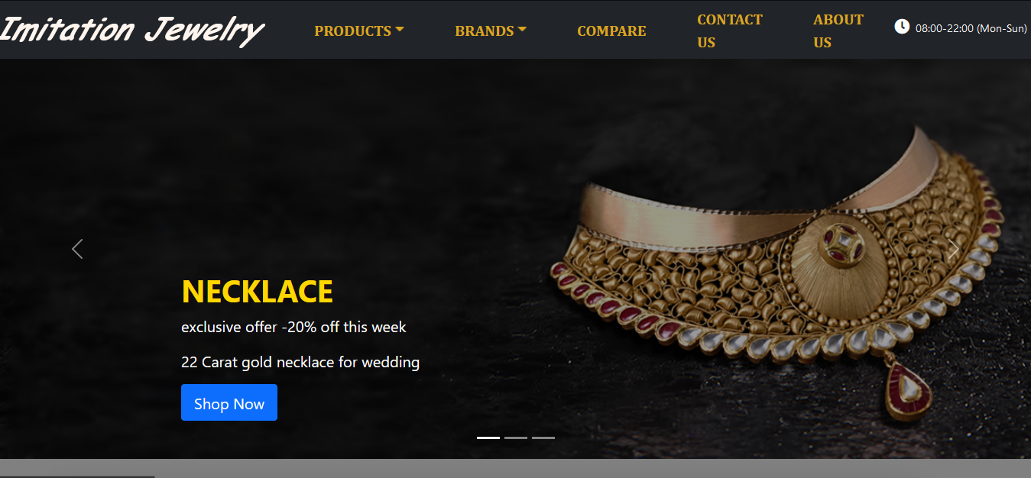

**Figure 1.1:** Homepage slideshow

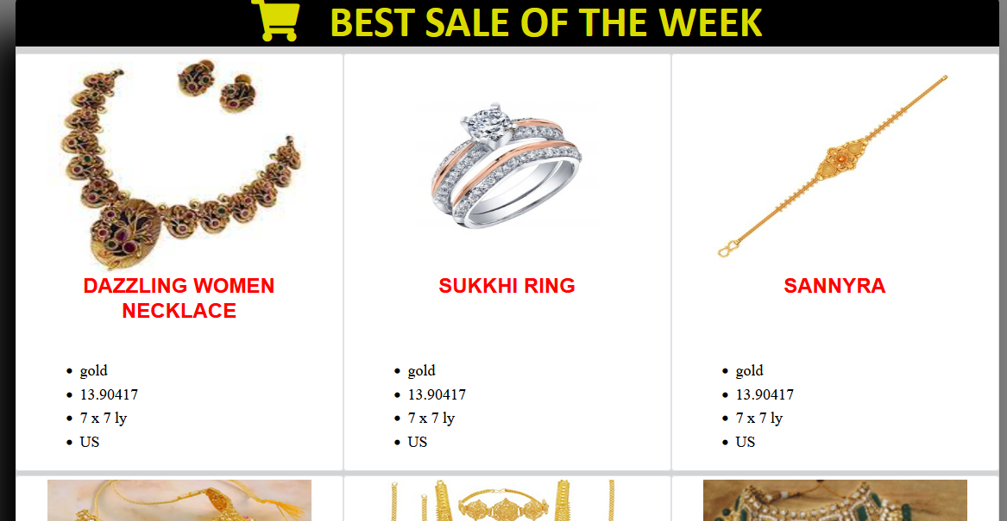

**Figure 1.2:** Homepage slideshow



**Figure 1.3:** Footer

1. **PRODUCTS:**

* Description

This page contains various products with their information sorted by their type (Artificial Jewelry, Original Jewelry, Semi_Precious Jewelry). People can also search products by their names or prices and filter them. The details products will be shown when clicking on them.

A Word document containing detailed information of each product can be downloaded by clicking a button the detailed product page.

* Screenshot

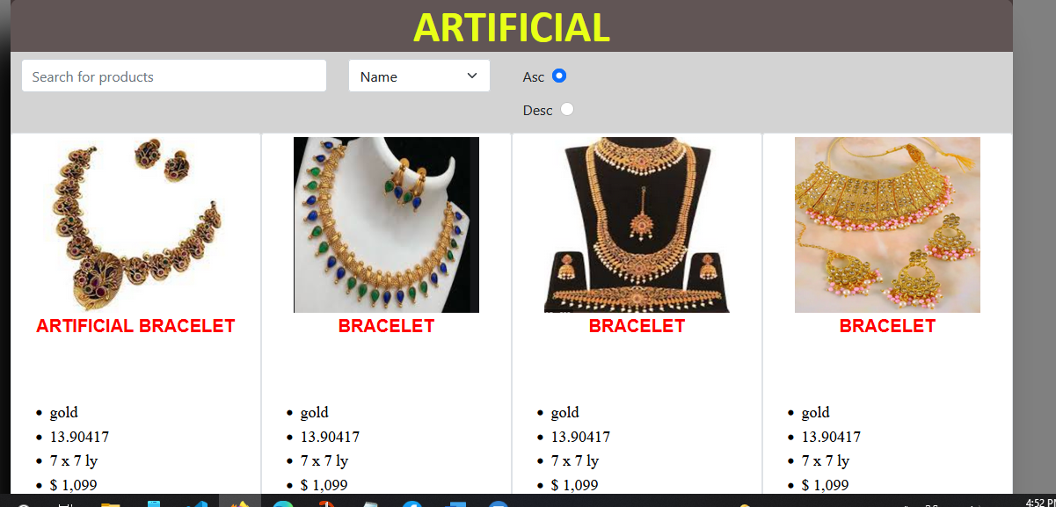

**Figure 2.1:** Artificial Jewelry

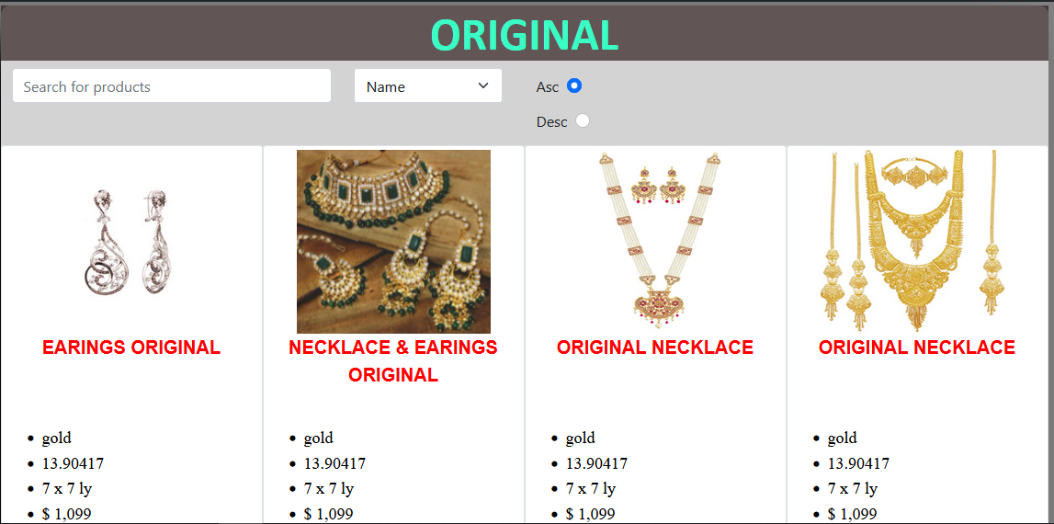

**Figure 2.2:** Original Jewelry

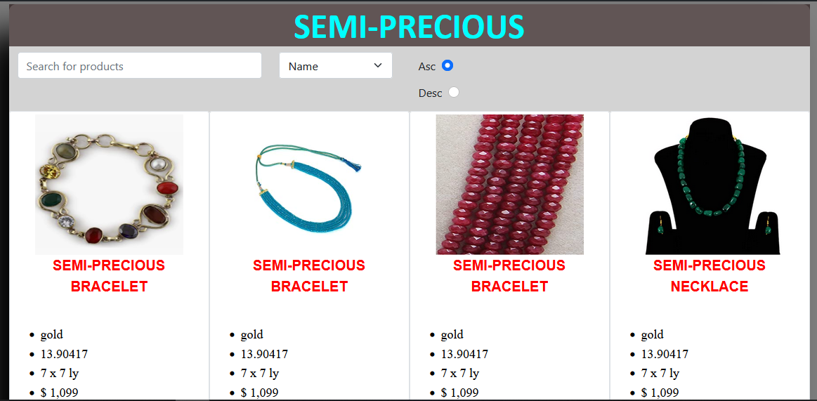

**Figure 2.3:** Semi_Precious Jewelry

1. **BRANDS:**

* Description

This is also a page of products on sale with details but sorted by brands of the products (Sukkhi , Dazzling & Sannyra). People can also search the item by filtering by their names or prices. The details products will be shown when clicking on them. A Word document containing detailed information of each product can be downloaded by clicking a button the detailed product page.

* Screenshot

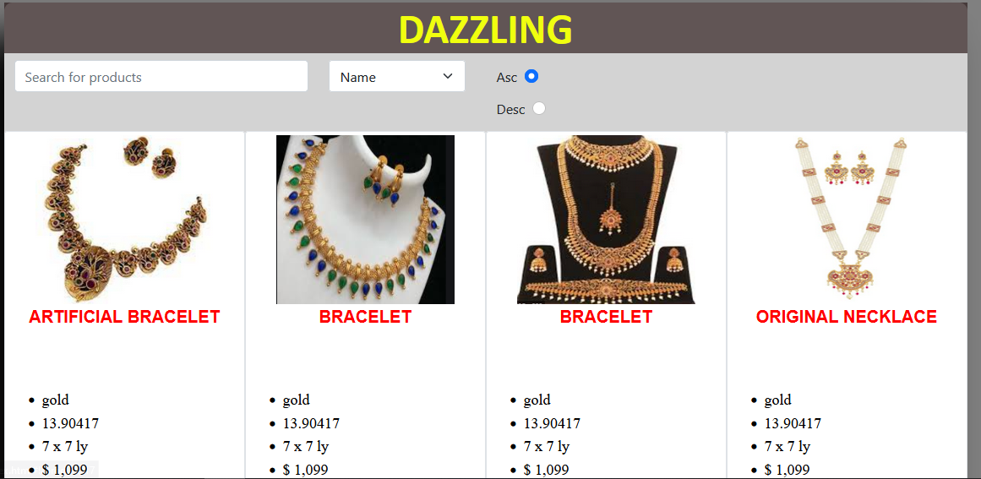

**Figure 3.1:** Dazzling products

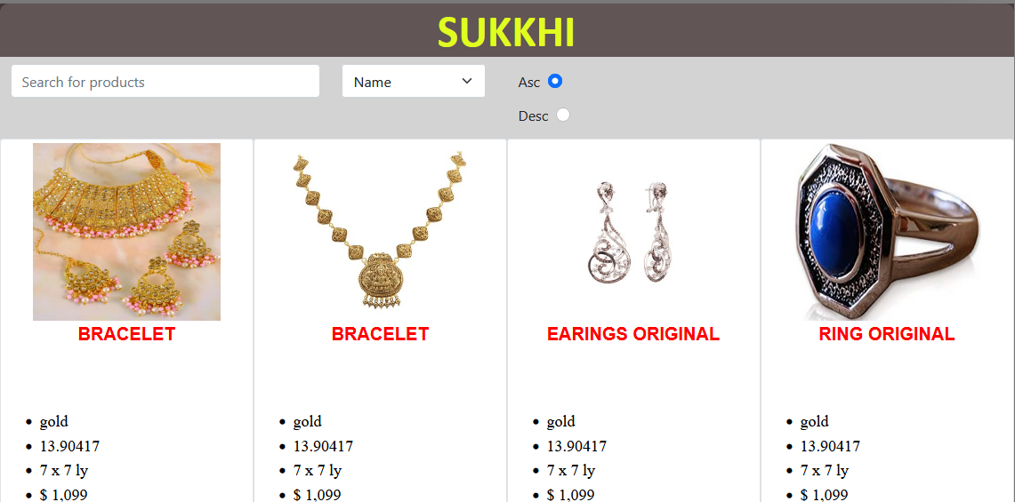

**Figure 3.2:** Sukkhi products

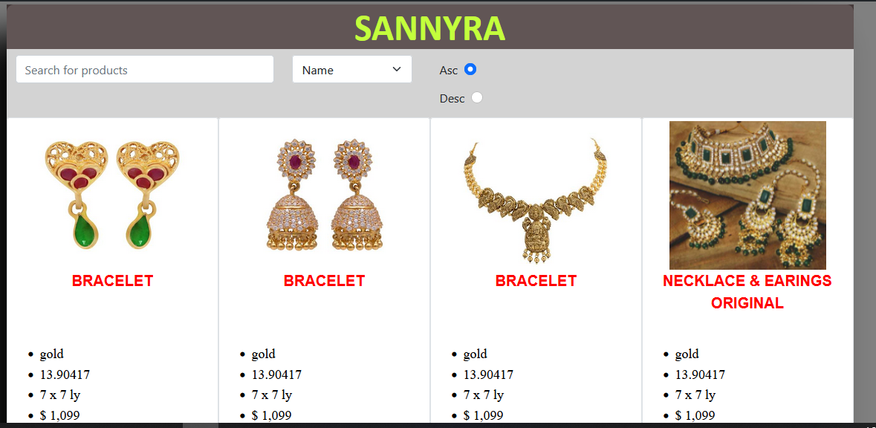

**Figure 3.3:** Sannyra products

1. **COMPARE PAGE:**

* Description:

Customers can compare visually 2 products by selecting their names. All the details information of those products will be displayed.

* Screen shot

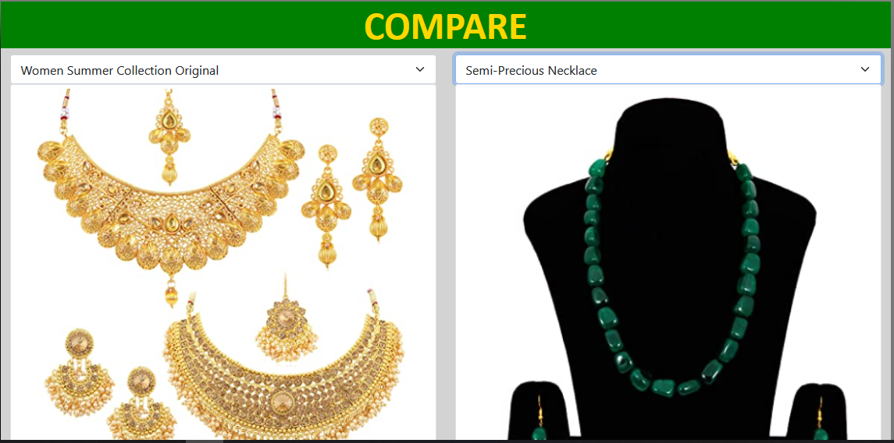

1. **CONTACTUS PAGE:**

* Description:

The information of Imitiation Jewelry along with the form including the message that customer want to give the management team are given in this page. A google map about the location of the company is also provided here.

* Screen shot

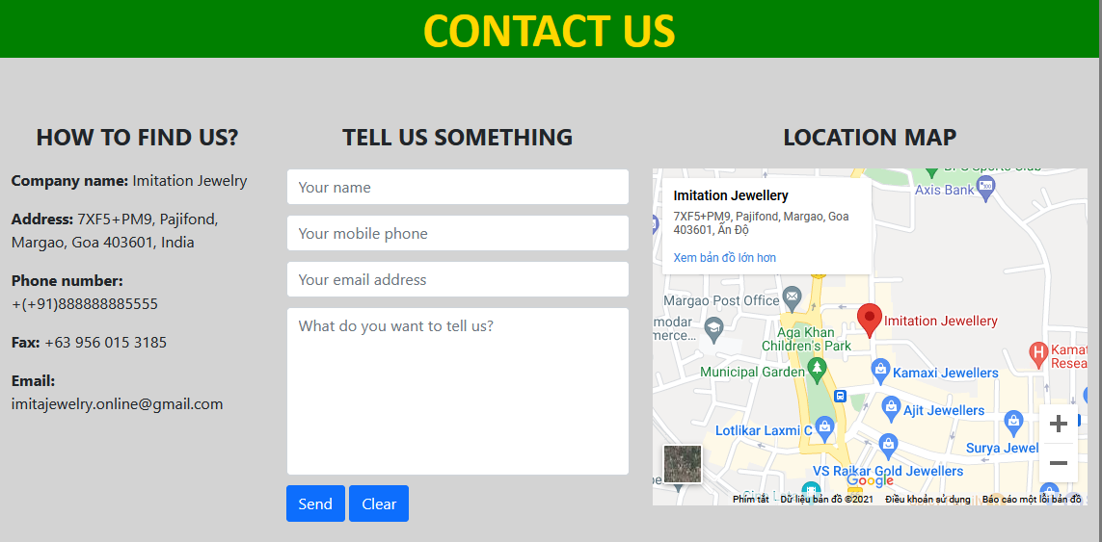

1. **ABOUTUS PAGE:**

* Description:

This is the page about the history and the scope of the company. This include the important milestones of the company’s lifetime up to now. It also shares some stories about the development of Imitiation Jewelry and also the scope, the vision in the future.

* Screen shoot

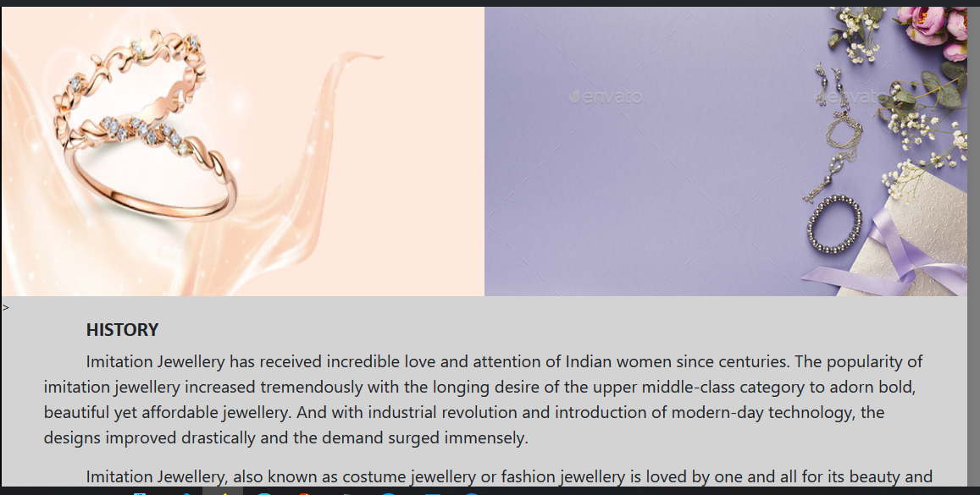

**HTML, CSS, JAVASCRIPT DESCRIPTION**

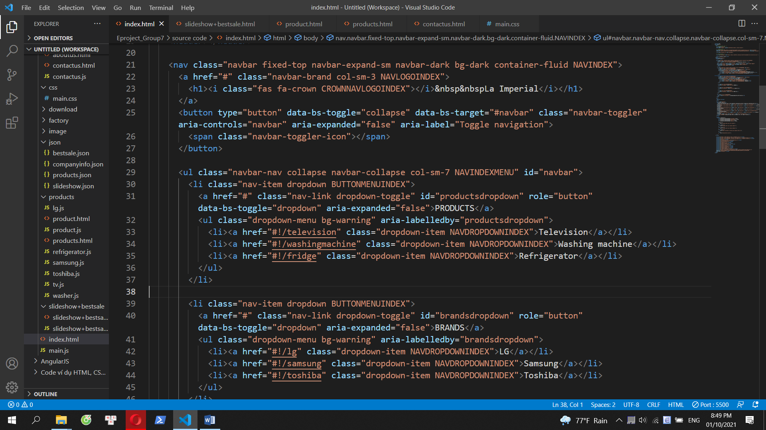

**Home page**

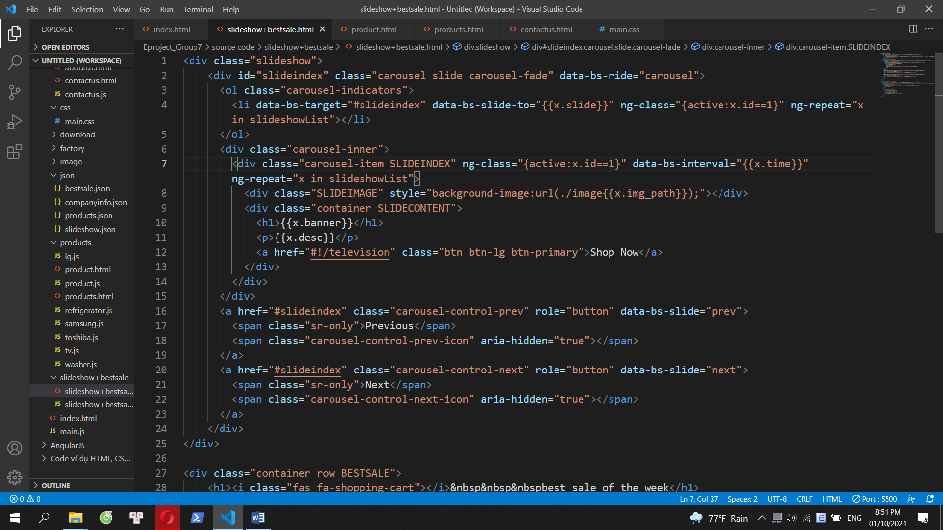

**Slideshow**

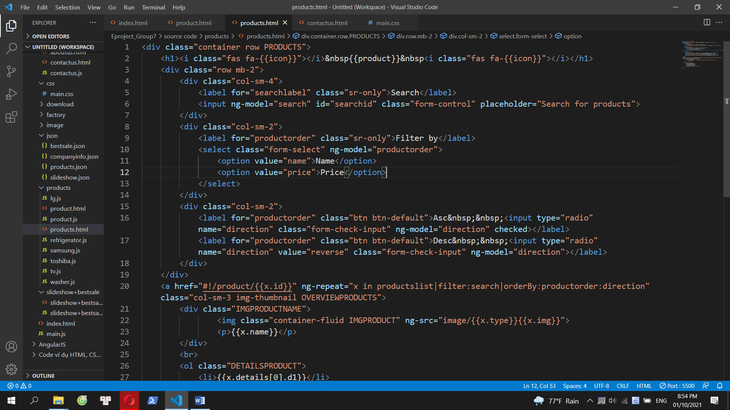

**Products page**

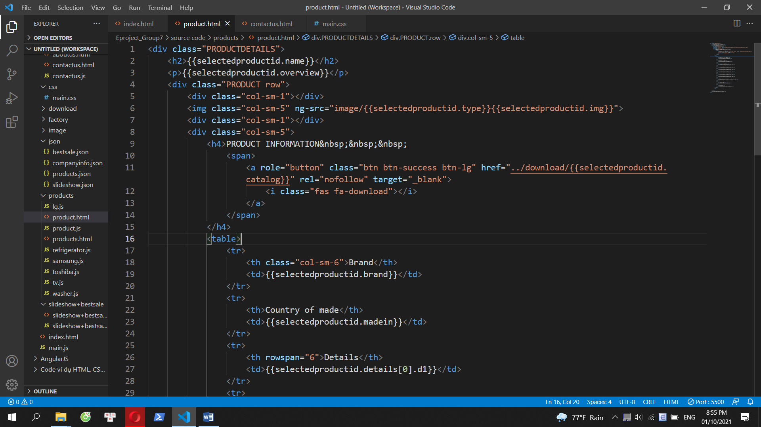

**Product details page**

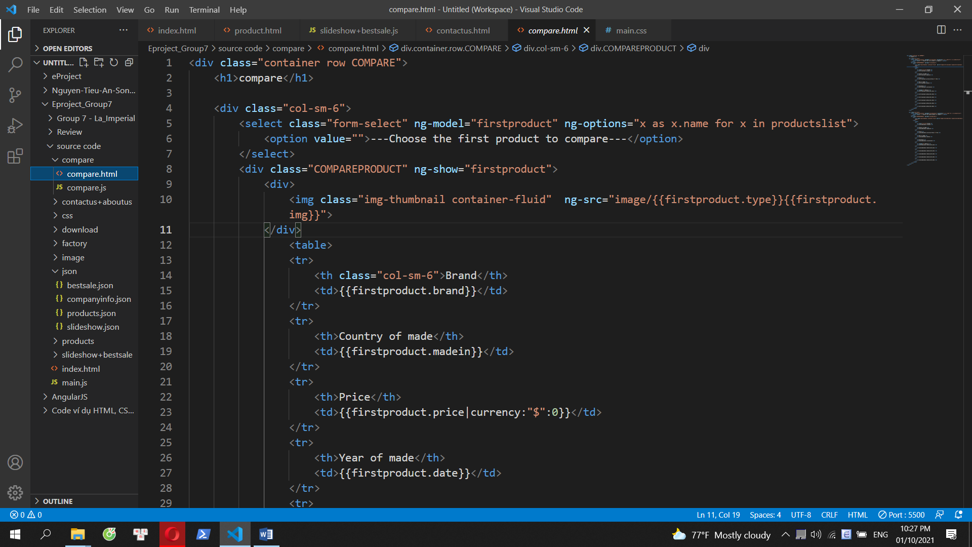

**Compare page**

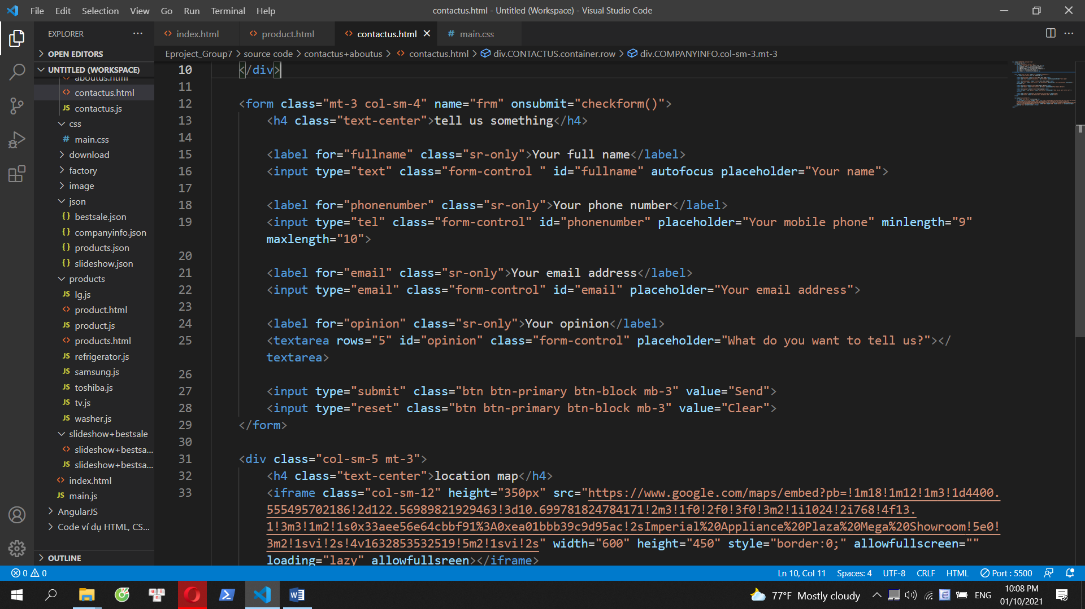

**Contact Us page**

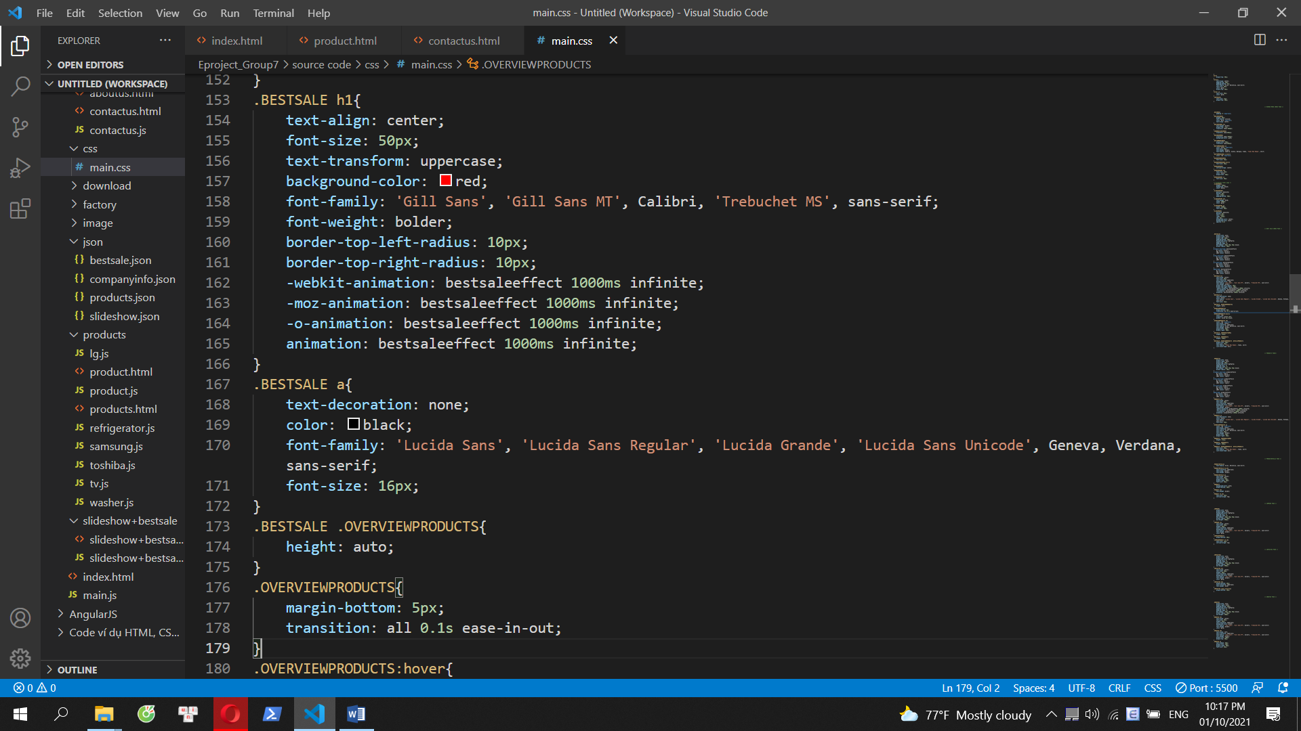

**main.css**

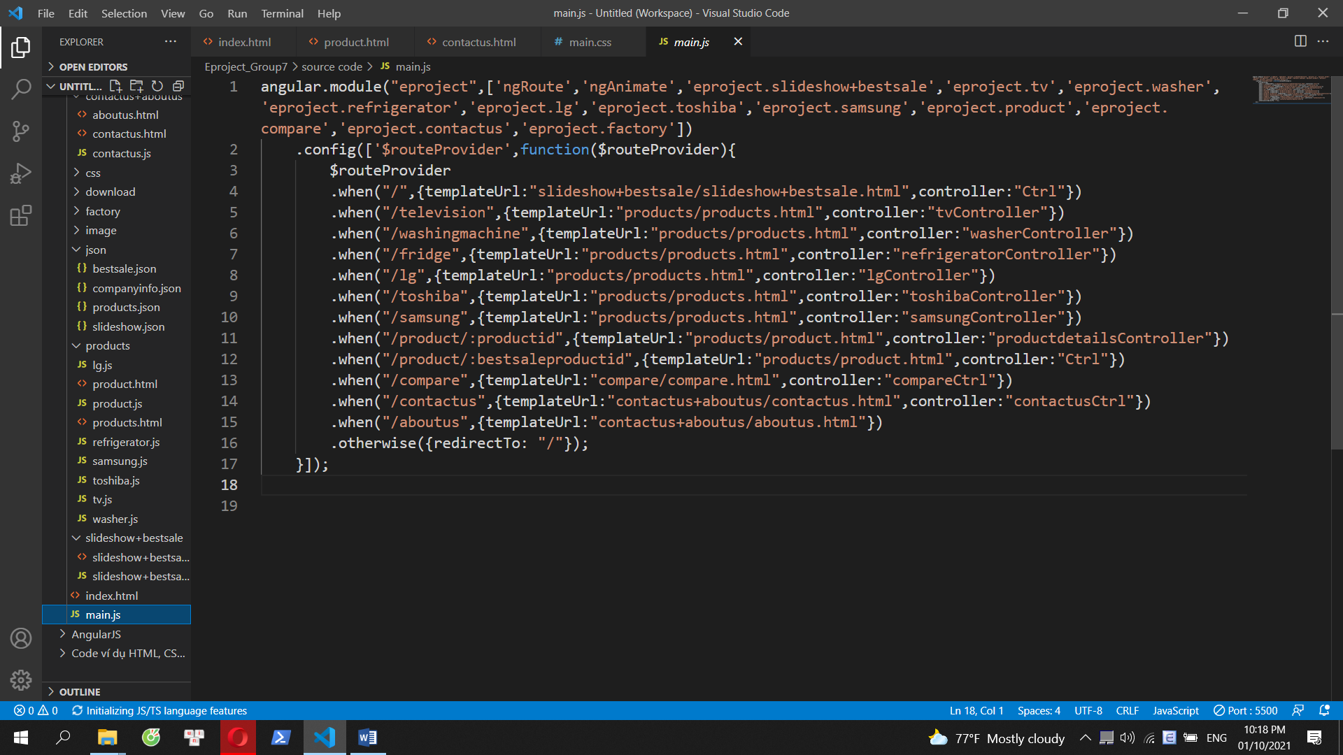

**main.js**

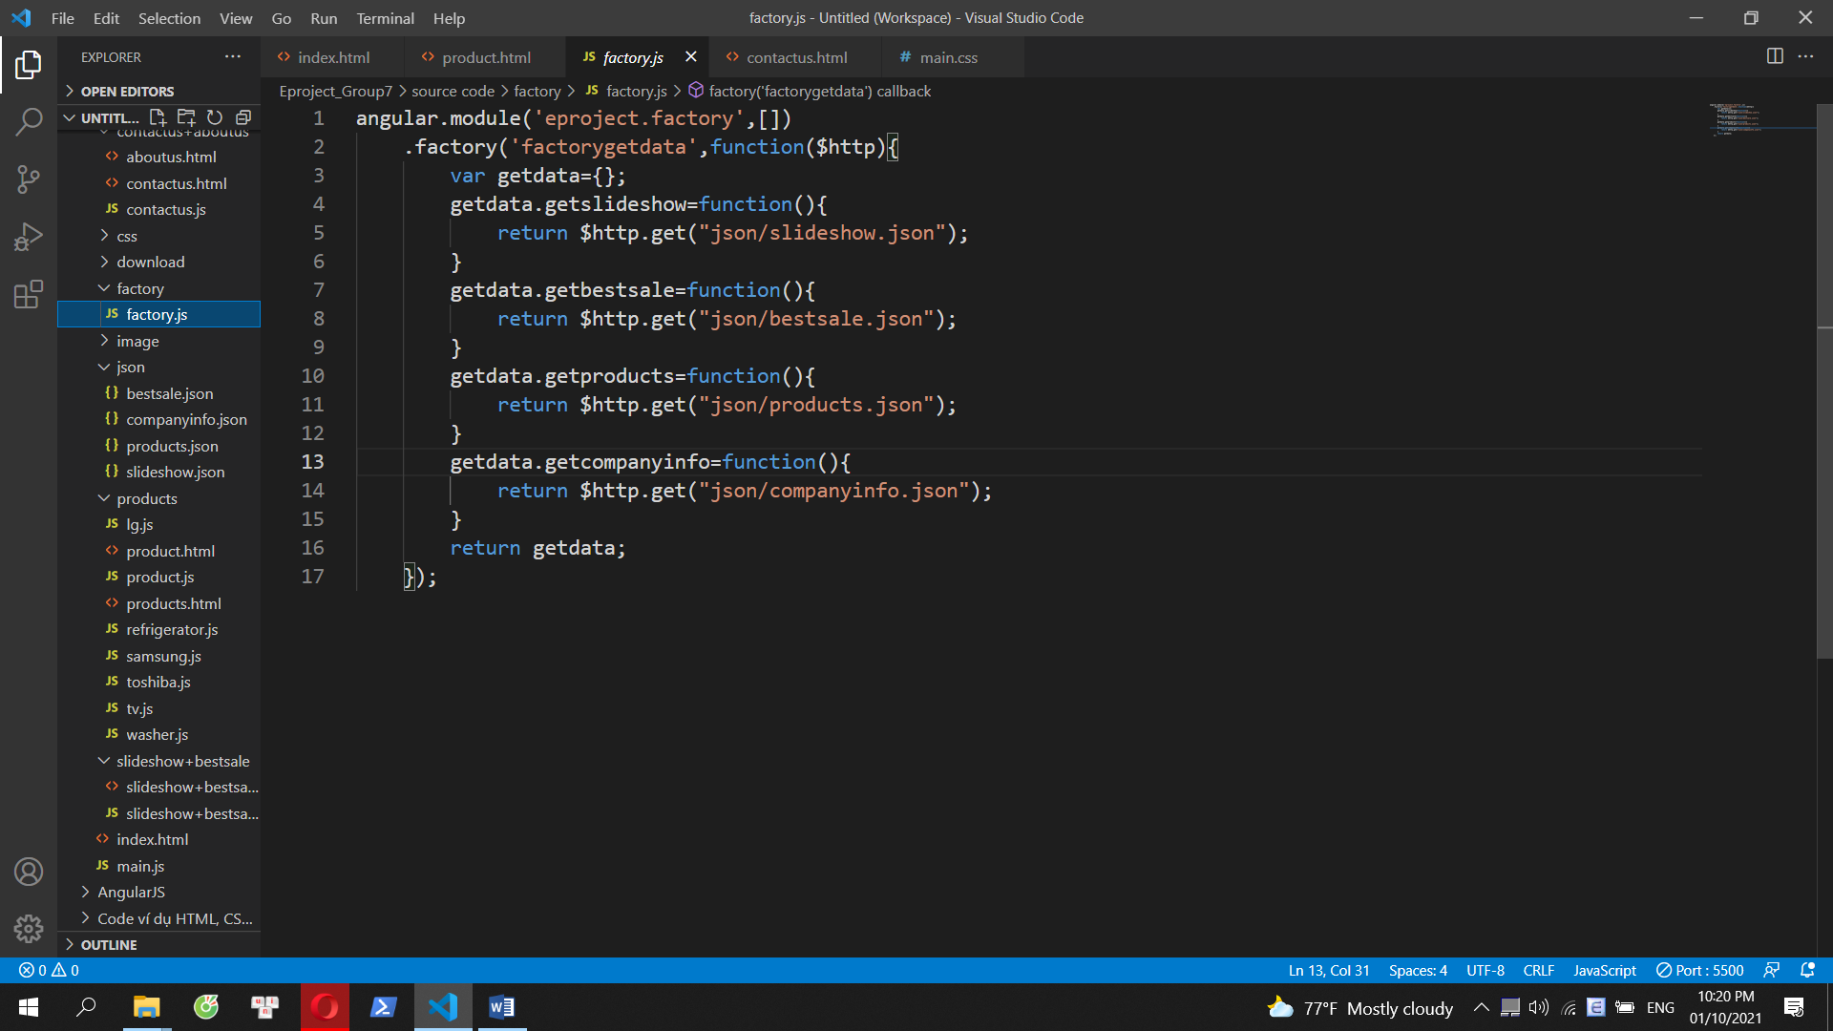

**factory.js**

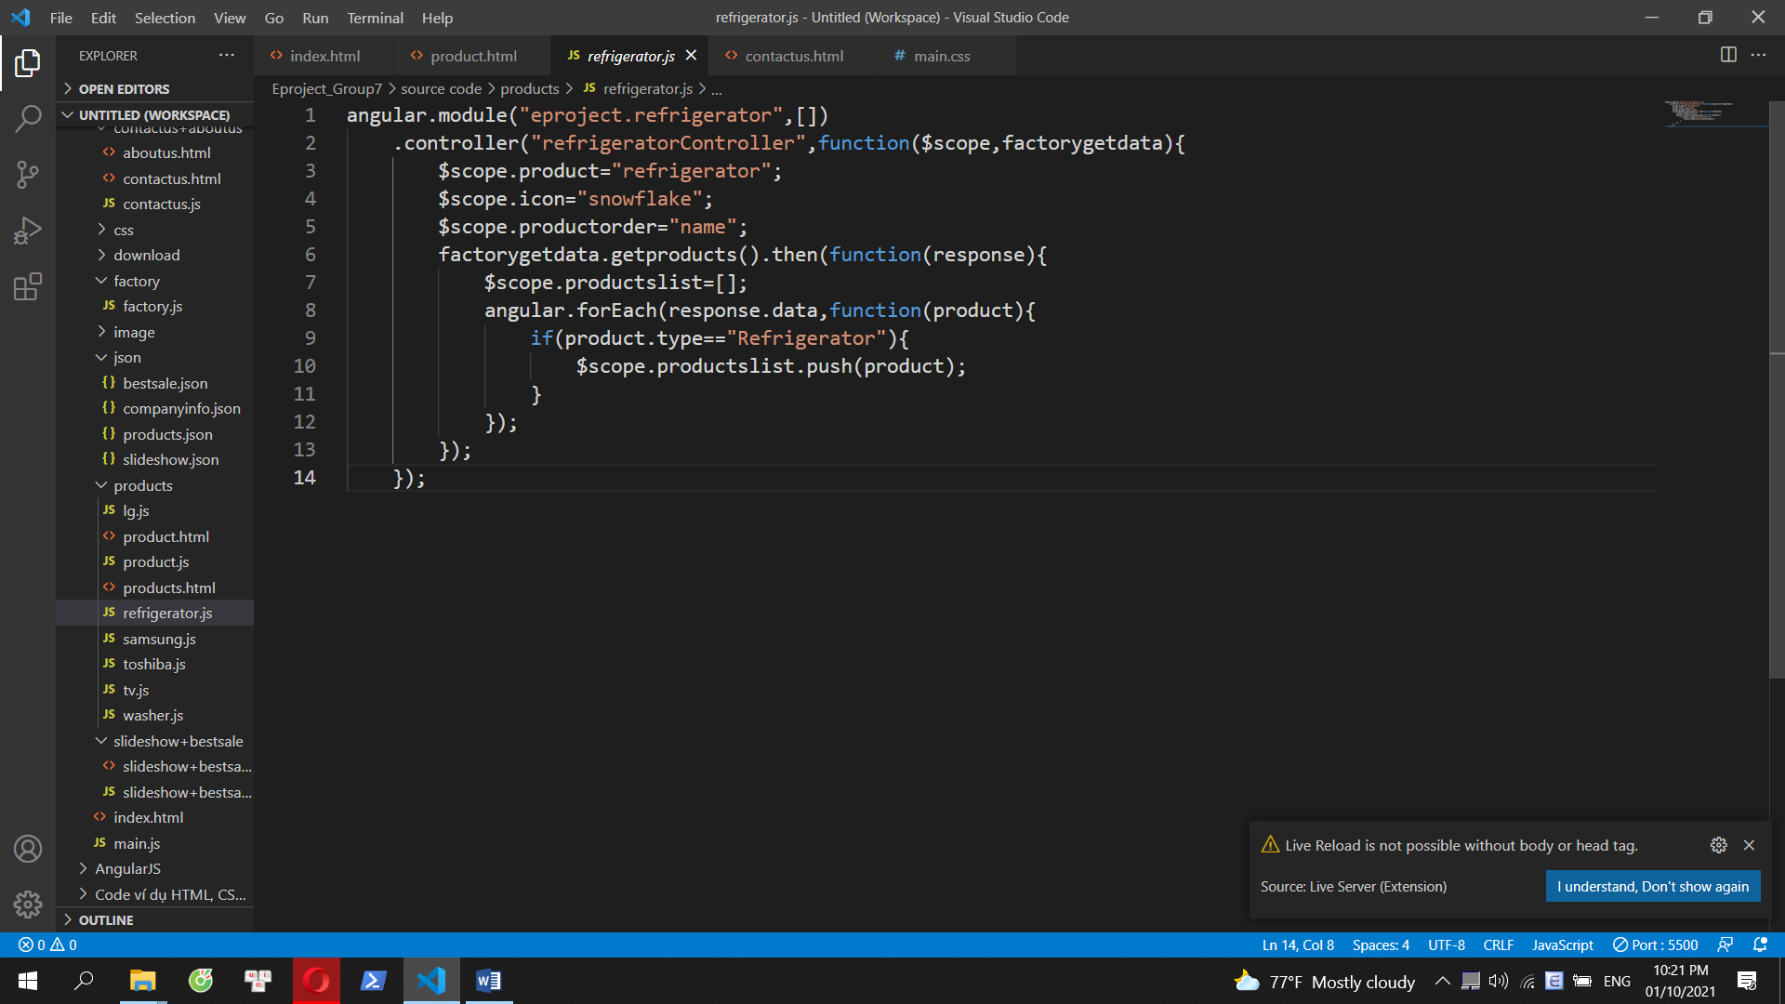

**One of the js files to control modules**

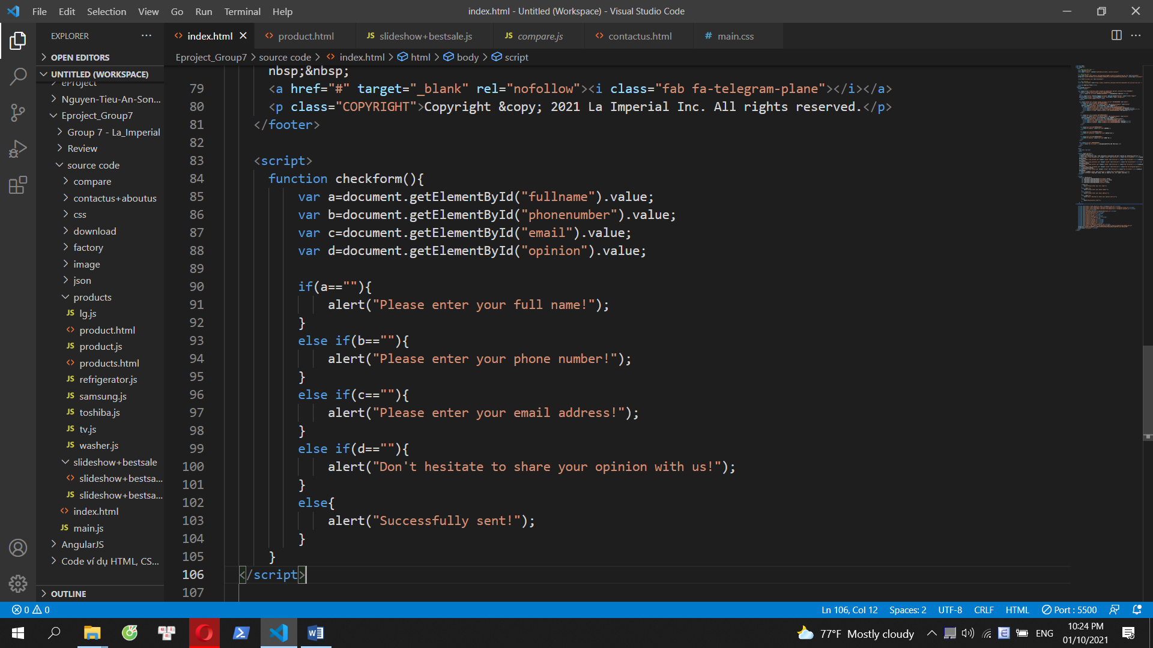

**Javascript**

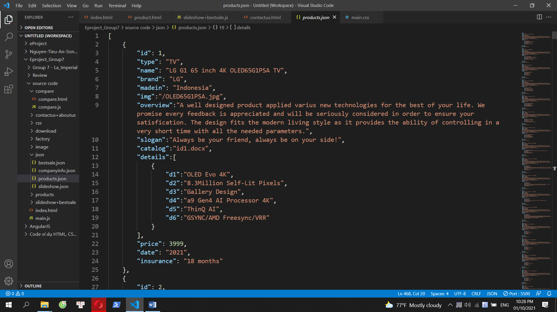

**json file**

# TASK SHEET REVIEW 3

|  |  |  |  |  |  |  |  |
| --- | --- | --- | --- | --- | --- | --- | --- |
| **Project Ref. No.:**  **eP/Advertisement**  **Portal Management System/01** | | **Project Title:** | **Activity Plan Prepared By:** | **Date of Preparation of Activity Plan:** | | | |
| **Sr.**  **No.** | **Task** | **Actual**  **Start Date** | **Actual Days** | **Team**  **Mate Names** | **Status** |
| 1 | Home page | **ImitationJewelry** | Thinh | 27-Sep-2021 | 1 | Tin | Completed |
| 2 | Products | 27-Sep-2021 | 1 | Tin | Completed |
| 3 | Brands | 28-Sep-2021 | 1 | Tin | Completed |
| 4 | Compare | 28-Sep-2021 | 1 | Tin | Completed |
| 5 | Contact us | 29-Sep-2021 | 1 | Duc | Completed |
| 6 | About us | 30-Sep-2021 | 1 | Duc | Completed |
| 7 | json | 01-Oct-2021 | 1 | Tin | Completed |
| 8 | Task sheet | 04-Oct-2021 | 1 | Duc | Completed |

|  |  |
| --- | --- |
| **Date: 05/10/2021** | |
| Signature of Instructor:  **Mr. Nguyen Phat Tai** | Signature of Team Leader:  **Mr. Ngo Trung Tin** |